# **MEAN STACK DEVELOPMENT**

**Description**

MEAN Stack is a user-friendly full-stack combination of JavaScript and its frameworks that are a supreme medium for creating dynamic websites. MEAN Stack is an abbreviation of JavaScript-based technologies — MongoDB, Express.js, [Angular](https://www.thinkwik.com/angularjs-development.html), and [Node.js](https://www.thinkwik.com/nodejs-development.html).

**MEAN Stack Core Components**

* **MongoDB – It** is a schema less NoSQL database system.
* **Express – It** is a framework used to build web applications in Node.
* **Angular – It** is a JavaScript framework used for front end design.
* **Node.js – It** is a server-side JavaScript execution environment.

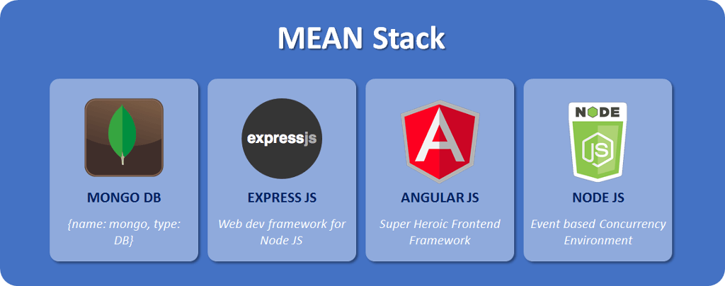

* **MongoDB**

MongoDB is the first component of the Mean Stack frame and is considered as the prominent NoSQL database, which makes the business more scalable. MongoDB is a sagacious choice for developers when it comes to managing tons of data containing massive tables. Opposing to any other database, MongoDB saves data in a binary JSON format and does not require updating the entire table, which makes even easier to transfer the data between client and server.

* **Express**

Express, inspired by the popular Ruby framework, Sinatra, is a lightweight and flexible node.js framework that builds web applications and provides plenteous features to create a single or multi-page web applications.

* **Angular**

Developed by the colossal company like Google, Angular is a front-end JavaScript framework for developing the single-page applications which comes with the handy features like the two-way data binding. Angular gives you the absolute solution to develop fast and amazing front-end apps.

* **Node.js**

Last but not the least component of MEAN Stack is Node.js, which is a runtime environment for JavaScript execution and performs beyond a traditional web server. Node.js is built on Google Chrome’s V8 JavaScript runtime that helps build extremely ascendible and contemporary web applications at a rapid pace. Node.js works on multi-platforms like Windows, Linux and OS X. Moreover, Node.js provides a server-side solution, which enables the JavaScript implementation on both client and server-side. Such features make the application development with MEAN Stack more effective and efficient. Let’s take a look at the other benefits of MEAN Stack.

**MEAN Stack Architecture**

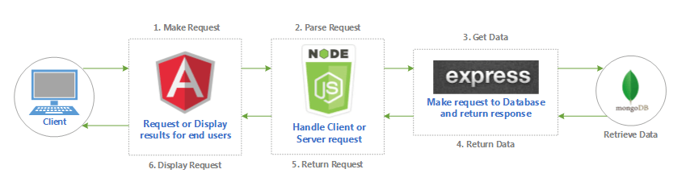

**Step by Step Process**

The entire working of mean stack can be explained in 5 steps:

* **Step 1:** Client makes a request first, which is handled by AngularJS.
* **Step 2:** Then, the request will be passed onto the NodeJS Server called as a parse request.
* **Step 3:** In step3 the ExpressJS will call MongoDB to set the data, the MongoDB retrieves the requested data and returns to ExpressJS.
* **Step 4:** NodeJS will return the requested data to the client.
* **Step 5:** In the final step AngularJS will display the result fetched from MongoDB.

**What we learn?**

MEAN Stack is a revolutionary movement in the field of [web development](https://www.thinkwik.com/web-application-development.html)as it offers some great features along with an up-to-date and effective approach to web development. It gives you all the features and support a [Mean Stack Developer](https://www.thinkwik.com/contact-us.html) might need. Unlike the other traditional web applications, MEAN Stack uses the state-of-the-art single-page applications, which do not require the whole web page to be refreshed for each server request. Moreover, the [MEAN Stack development company](https://www.thinkwik.com/mean-stack-development-company.html) keeps it in mind the use and nature of the framework and grab all its advantages to make up a great web application.

**Job Opportunities**

Being, a Mean stack developer is highly desirable and challenging. So, if you are ready to work on the diverse skill set and have the experience of working with various code languages and application, then you will become successful MEAN stack developer.

Application Architecture (Technical Architect) is an area you can easily progress in the future after gaining experience as a mean stack developer.

By leaning the MEAN stack (JavaScript technologies), you’ll have a wide range of domains to choose from. Web, mobile, desktop and even IoT, because all these frameworks are built on top of JavaScript you can easily hop between frameworks, provided you have a good understanding of JavaScript.